A
PROJECT REPORT ON

DRIVER DROWSINESS DETECTION SYSTEM

Submitted By

Under the guidance of
PRANJALI R. HIWALE | 1910121245041
ANAND A. KALSAIT | 41101220181124510023
KISHORI Y. CHOUKADE | 41101220181124510033
AISHWARYA S. PURI | 41101220181124510004
PROF. DHIRAJ D. SHIRBHATE

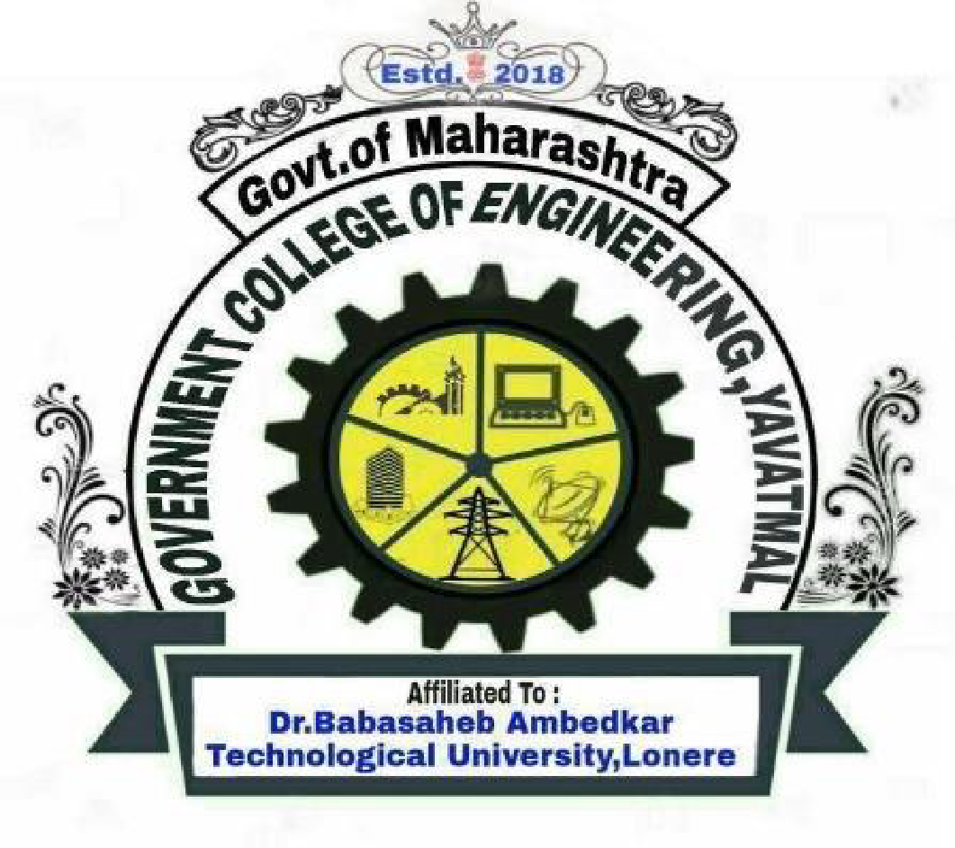

DEPARTMENT OF COMPUTER ENGINEERING
GOVERNMENT COLLEGE OF ENGINEERING, YAVATMAL
2021-2022

CERTIFICATE

This is to certify that the Project report entitled
“DRIVER DROWSINESS DETECTION SYSTEM”
is a bonafide work and it is submitted to Government College of Engineering, Yavatmal

SUBMITTED BY:

The report has been approved as it satisfies the academic requirements in respect of major project work prescribed the course
PRANJALI R. HIWALE | PRN: 1910121245041
ANAND A. KALSAIT | PRN: 41101220181124510023
KISHORI Y. CHOUKADE | PRN: 41101220181124510033
AISHWARYA S. PURI | PRN: 41101220181124510004

Prof. D. D. Shirbhate  (Project Guide)  Department of Computer Engineering Government College of Engineering, Yavatmal | Prof. S. S. Thorat  (Head of the Department)  Department of Computer Engineering  Government College of Engineering, Yavatmal
Dr. P. M. Khodke
(Principal)
Government College of Engineering, Yavatmal
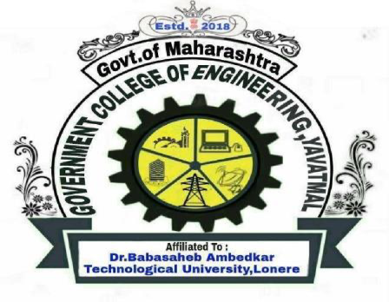

DEPARTMENT OF COMPUTER ENGINEERING
GOVERNMENT COLLEGE OF ENGINEERING, YAVATMAL
2021-2022
DEPARTMENT OF COMPUTER ENGINEERING
GOVERNMENT COLLEGE OF ENGINEERING YAVATMAL

This is to certify that the Project report entitled
“DRIVER DROWSINESS DETECTION SYSTEM”

SUBMITTED BY:
PRANJALI R. HIWALE
ANAND A. KALSAIT
KISHORI Y. CHOUKADE
AISHWARYA S. PURI

in the partial fulfillment for the award of B. Tech in COMPUTER ENGINEERING. This project report is reward of the work carried out by them under our Guidance and supervision during the year 2021-2022

PROF. D. D. Shirbhate
(Project Guide)
Department of Computer Engineering
Government College of Engineering, Yavatmal

Internal Examiner External Examiner

